Computer Language Coding Concepts

Parameters in an Active Clause in a Diagram
Parameters in an active clause have been conceptually explained in the article Parameters in an Active Clause.

This article only illustrates how parameters in an active clause look in a diagram.

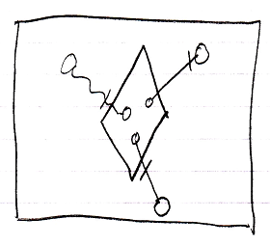

The large square is a command definition the inactive clause is in. The diamond inside the square is the active clause. The diamond contains three circles, which are the parameters in the clause. The circles inside the diamond are connected to the circles outside the diamond with parameter passings. Parameter passings are explained in the parameter articles.

The creation behavior of parameters in an active clause will not be further explained with diagrams in this article. Refer to the article Creation Behavior of Command Callls in a Diagram for an illustration of how the creation behavior of command calls looks in a diagram.

See also: Parameters in an Active Clause,
Creation Behavior of Command Calls in a Diagram

Author & Copyright: Jan-Joost van Zon Date: August 9, 2008 – August 9, 2008 Location: Oosterhout, The Netherlands Status: Under Construction | Finished

